**Objective:-** Create employee_master table and check if user is authenticated or not by login module and set appropriate session. Every time whenver user loged in the last Access Time should be shown to user. give logout link and destory the session attributes and redirect the user to again login page.

**Code :-**

**src/main/webapp/login.jsp**

<%@ page contentType="text/html;charset=UTF-8" language="java" %>  
  
<!DOCTYPE html>  
<html lang="en">  
<head>  
 <meta charset="UTF-8">  
 <title>Login Page</title>  
 <link href="https://fonts.googleapis.com/css2?family=Poppins:wght@400;500;600&display=swap" rel="stylesheet">  
 <style>  
 * {  
 margin: 0;  
 padding: 0;  
 box-sizing: border-box;  
 }  
  
 body {  
 font-family: 'Poppins', sans-serif;  
 background: linear-gradient(135deg, #74EBD5, #ACB6E5);  
 min-height: 100vh;  
 display: flex;  
 justify-content: center;  
 align-items: center;  
 }  
  
 .login-container {  
 background: #ffffff;  
 width: 90%;  
 max-width: 400px;  
 padding: 40px;  
 border-radius: 12px;  
 box-shadow: 0 10px 30px rgba(0, 0, 0, 0.2);  
 transition: 0.3s ease;  
 }  
  
 .login-container:hover {  
 box-shadow: 0 15px 40px rgba(0, 0, 0, 0.3);  
 }  
  
 h2 {  
 text-align: center;  
 color: #333;  
 margin-bottom: 25px;  
 font-size: 28px;  
 font-weight: 600;  
 }  
  
 form {  
 display: flex;  
 flex-direction: column;  
 gap: 15px;  
 }  
  
 label {  
 text-align: left;  
 font-weight: 500;  
 color: #555;  
 font-size: 16px;  
 }  
  
 input {  
 padding: 12px;  
 border: 1px solid #ccc;  
 border-radius: 8px;  
 font-size: 16px;  
 transition: 0.3s;  
 font-family: 'Poppins', sans-serif;  
 }  
  
 input:focus {  
 outline: none;  
 border-color: #4CAF50;  
 box-shadow: 0 0 8px #4CAF50;  
 }  
  
 button {  
 background: #4CAF50;  
 color: white;  
 border: none;  
 padding: 12px;  
 border-radius: 8px;  
 font-size: 18px;  
 font-weight: 500;  
 cursor: pointer;  
 transition: 0.3s;  
 }  
  
 button:hover {  
 background: #45a049;  
 }  
  
 .footer-text {  
 margin-top: 15px;  
 font-size: 14px;  
 color: #777;  
 text-align: center;  
 }  
  
 .footer-text a {  
 color: #007BFF;  
 text-decoration: none;  
 }  
  
 .footer-text a:hover {  
 text-decoration: underline;  
 }  
  
 @media (max-width: 768px) {  
 .login-container {  
 width: 95%;  
 padding: 25px;  
 }  
  
 h2 {  
 font-size: 24px;  
 }  
 }  
 </style>  
</head>  
<body>  
 <div class="login-container">  
 <h2>Login</h2>  
 <form action="LoginServlet" method="post">  
 <label for="username">Username</label>  
 <input type="text" id="username" name="username" required>  
  
 <label for="password">Password</label>  
 <input type="password" id="password" name="password" required>  
  
 <button type="submit">Login</button>  
 </form>  
 </div>  
</body>  
</html>

**src/main/webapp/UserAccount.jsp**

<%@ page contentType="text/html;charset=UTF-8" language="java" %>  
<!DOCTYPE html>  
<html>  
<head>  
 <title>User Account</title>  
 <link href="https://fonts.googleapis.com/css2?family=Poppins&display=swap" rel="stylesheet">  
 <style>  
 * {  
 margin: 0;  
 padding: 0;  
 box-sizing: border-box;  
 }  
  
 body {  
 font-family: 'Poppins', sans-serif;  
 background: linear-gradient(135deg, #74EBD5, #ACB6E5);  
 min-height: 100vh;  
 display: flex;  
 justify-content: center;  
 align-items: center;  
 }  
  
 .container {  
 background: #ffffff;  
 width: 90%;  
 max-width: 500px;  
 border-radius: 12px;  
 box-shadow: 0 10px 30px rgba(0, 0, 0, 0.2);  
 padding: 40px;  
 text-align: center;  
 transition: 0.3s ease;  
 }  
  
 .container:hover {  
 box-shadow: 0 15px 40px rgba(0, 0, 0, 0.3);  
 }  
  
 h1 {  
 font-size: 28px;  
 color: #333;  
 font-weight: 800;  
 margin-bottom: 20px;  
 }  
  
 h1 {  
 font-size: 20px;  
 color: #333;  
 font-weight: 400;  
 margin-bottom: 20px;  
 }  
  
 .logout-link {  
 margin-top: 20px;  
 padding: 12px 20px;  
 background-color: #4CAF50;  
 border: none;  
 border-radius: 8px;  
 color: white;  
 font-size: 16px;  
 font-weight: 500;  
 cursor: pointer;  
 transition: 0.3s;  
 text-decoration: none;  
 display: inline-block;  
 }  
  
 .logout-link:hover {  
 background-color: #45a049;  
 }  
  
 @media (max-width: 768px) {  
 .container {  
 width: 95%;  
 padding: 25px;  
 }  
 }  
 </style>  
</head>  
<body>  
 <%  
 if (session == null || session.getAttribute("username") == null) {  
 response.sendRedirect("index.jsp");  
 return;  
 }  
 %>  
 <div class="container">  
 <h1>Welcome, <%= session.getAttribute("username") %>!</h1>  
 <p>Last Login Time is , <%= session.getAttribute("lastlogintime") %></p>  
 <a href="logout.jsp" class="logout-link">Logout</a>  
 </div>  
</body>  
</html>

**src/main/webapp/logout.jsp**

<html>  
<head>  
 <title>Logout</title>  
</head>  
 <body>  
 <%  
 session.invalidate();  
 response.sendRedirect("index.jsp");  
 %>  
 <h1>Logout Successful.</h1>  
 <br> <br>  
 <a href="login.jsp">Login</a>  
 </body>  
</html>

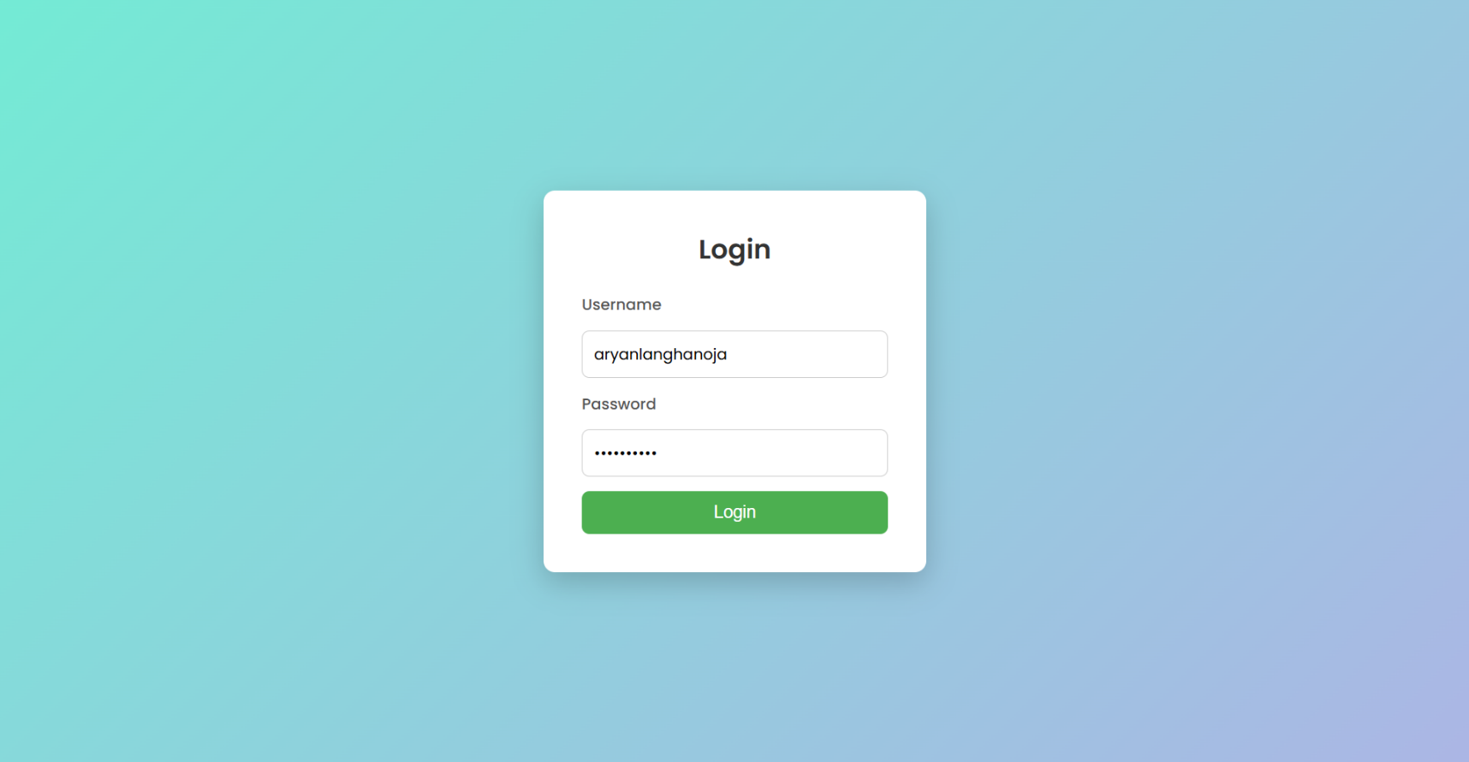**Output:-**

